Notes to contributors of Acta Climatologica et Chorologica [Do not use Caps Lock when you write the Title or the Authors!]
I Author¹, J Author¹ and K author²
¹Institution, University, address or P.O.Box, City, Country
²Institution, University, address or P.O.Box, City, Country
E-mail: author@geo.u-szeged.hu
Summary: Please read these notes carefully and follow them precisely. This document explains how to prepare a paper for Acta Climatologica et Chorologica. It can also be used as a template if you are using Microsoft Word with all formatting styles embedded. Text in [square brackets] gives the ‘style’ label used and some overview on layout and style and should be deleted in your submitted paper. [Abstract: Times New Roman, 8pt]
Key words: Acta Climatologica et Chorologica, template [Key words: Times New Roman, 8pt]
1. INTRODUCTION [Heading Level 1: Times New Roman, 10pt]
Authors may be of any nationality, but the official language of the journal is English. Papers will be reviewed by unidentified referees. [Normal text: Times New Roman, 10pt]
Manuscripts should be sent Tamás Gál (tgal@geo.u-szeged.hu) in Microsoft Word format. The preferred medium for the text is MS Office 2002-2013 (.doc or .docx) and for the figures the CorelDraw 9-X3 or Excel 2002-2013 (.xls or .xlsx) (or in 300 dpi resolution, high quality .JPG or .TIF formats).
Acta Climatologica and Chorologica accepts papers continuously.
The accepted papers will be published in the next issue of Acta Climatologica et Chorologica, and also it will published online in the homepage of Department of Climatology and Landscape Ecology (http://www2.sci.u-szeged.hu/eghajlattan/ or http://www2.sci.u-szeged.hu/eghajlattan/kiadvanyok.htm).
2. Preparing the Manuscript
2.1. Length of Paper [Heading Level 2: Times New Roman, 10pt]
The final paper should be no more than 10 pages (B5 JIS) in length including all tables and figures and strictly adhere to the formatting guidelines provided here. Reviewers will enforce these guidelines strictly.
2.2. Title part, Summary, Key words
2.2.1. Title part [Heading Level 3: Times New Roman, 10pt]
Title part of the paper should contain the concise title, the name(s) of the author(s), the affiliation(s) including postal and E-mail address(es). In case of multiple authors, the cover letter should indicate the corresponding author.
2.2.1. Summary
Summary should follow the title, it contains the purpose, the data and methods as well as the basic conclusion. The Summary can be only one paragraph.
2.2.1. Key words
Key words are necessary to help to classify the topic.
2.3. Text, equations, tables, figures
The text should be Times New Roman, 10pt. The use of SI units are expected. The negative exponent is preferred to solidus. Decimal separator: “.”. Do not use footnotes.
Mathematical formulas are expected to be as simple as possible and numbered in parentheses at the right margin. We recommend to use Microsoft Equation 3.0 for editing the formulas. Do not use Microsoft Equation 3.0 objects inside the text.
(1)
Figures and tables should be consecutively numbered and referred to in the text. Tables should be marked Arabic numbers (Table 1) and set in the text together with their captions. Avoid too lengthy or complicated tables. Please enter an empty line after the tables.
Table 1 Table caption [Table caption: Times New Roman, 9pt]
SPI value | Category
>2 | Extremely wet
1.5 - 1.99 | Very wet
1 - 1.49 | Moderately wet
(-0.99) - 0.9 | Normal
(-1) - (-1.49) | Moderately dry
(-1.5) - (-1.99) | Very dry
< (-2) | Extremely dry
[Empty line: Times New Roman, 8pt]
Figures, diagrams, photos, maps should be marked Arabic numbers (Fig. 1) and set in the text together with their captions. Maximum size of a figure is 130 mm x 170 mm.
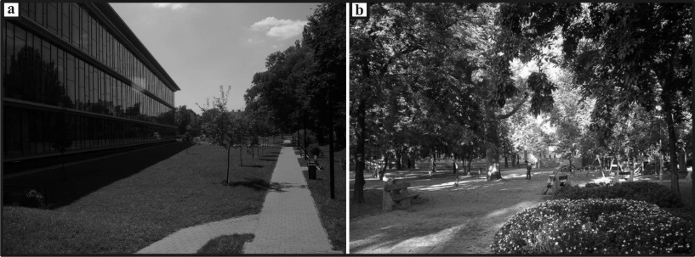
Fig. 1 Figure caption (a) info about the photo in left
(b) info about the photo in rigth [Figure caption: Times New Roman, 9pt]
Captions should be complete enough to allow appreciation of the illustration without referring to the main text. Make sure that illustrations are clear and easy to read. Avoid too lengthy or complicated figures. Images and graphics must be in black and white or greyscale for printing purposes. For example, use different fill patterns or line styles/markers which can be more easily distinguished when printed (Fig. 2).
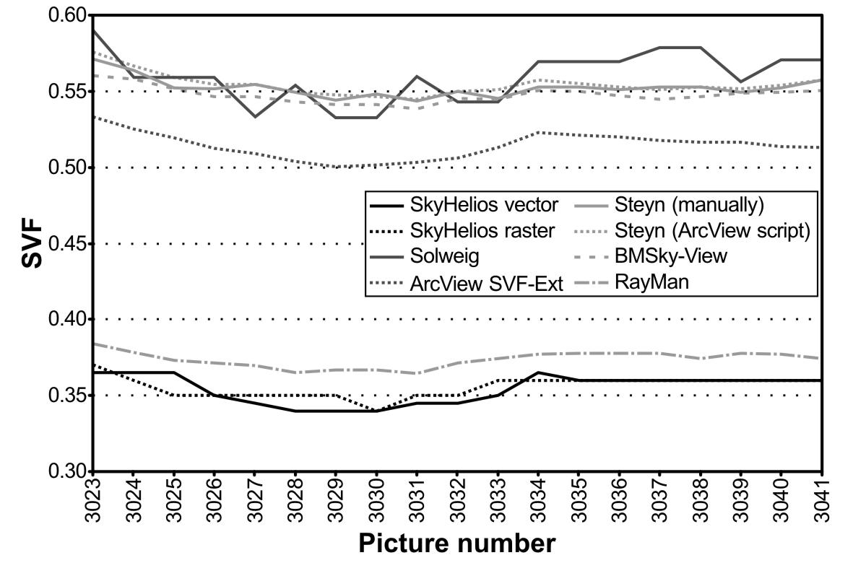
Fig. 2 Figure caption
Images and graphics can be colour in the online version of the paper, the colour figures have to be submitted separately using the following file formats: CorelDraw 9-X3, 300 dpi resolution, high quality .JPG or .TIF or Microsoft Excel. The name of the files should be numbered corresponding to the paper (Fig1.jpg, Fig2.tif, Fig3.cdr, etc).
2.4. References
The text citation should contain the name(s) of the author(s) in normal letter and the year of publication. In case of one author: Johnson (1989), or if the name of the author cannot be fitted into the text: (Johnson 1989); in the case of two authors: Holmer and Eliasson (1999); if there are more than two authors: Lu et al. (1997), in the case of several references in the same time (Oke 1973 1979 1988a 1988b, Lu et al. 1997, Holmer and Eliasson 1999). When referring to several papers published in the same year by the same author(s), the year of publication should be followed by letters a, b etc.
At the end of the paper the list of references should be arranged alphabetically (not like in this template, in the References we present the form of the different type of citations).
3. Conclusions
The simplest way to layout your paper is to use this document and the styles embedded in this document throughout (see Microsoft Word Help if you are unfamiliar with using Styles) and to follow the example of these guidelines.
Acknowledgements: The study was supported by the Scientific Research Fund (ABC S-1234). The authors’ special thank to the authors of the figures, and tables what is used here as an example.
REFERENCES
[Papers in international journals]
Holmer B, Eliasson I (1999) Urban-rural vapour pressure differences and their role in the development of urban heat islands. Int J Climatol 19:989-1009
Lu J, Arya SP, Snyder WH, Lawson RE Jr (1997) A laboratory study of the urban heat island in calm and stably stratified environment. Part 2. Velocity field. J Appl Meteorol 36:1392-1402
[Papers in journals, if the language is not eanglish, german, french]
Béres I, Novák R, Hoffmanné Pathy Zs, Kazinczi G (2005) Az ürömlevelű parlagfű elterjedése, morfológiája, biológiája, jelentősége és a védekezés lehetőségei. [Distribution, morphology, biology, importance and weed control of common ragweed. (in Hungarian)] Gyomnövények gyomirtás 6:1-48
[Book]
Anderberg MR (1973) Cluster analysis for applications. Academic Press, New York
Péczely Gy (1979) Éghajlattan. [Climatology. (in Hungarian)] Nemzeti tankönyvkiadó, Budapest
[Conference paper]
Souza LCL, Rodrigues DS, Mendes JFG (2003) The 3DSkyView extension: an urban geometry acces tool in a geographical information system. In: Klysik K, Oke TR, Fortuniak K, Grimmond CSB, Wibig J (eds) Proc. Fifth Int. Conf. on Urban Climate, Vol. 2. University of Lodz, Lodz, Poland. 413-416
[Other]
Census of Hungary (2001) Területi adatok 6.6. Csongrád megye II. kötet. [Local data 6.6. County of Csongrád volume 2. (in Hungarian)]
First Military Survey (1784) HMT [Map Collection of Museum of Hungarian Military History] 1:28800
OSZK-PKNyT [National Széchényi Library, Collection of Posters and Small Printings] (1891) Postcards/Nagymaros
[Journal title abbreviations available e.g. in this site: https://sites.google.com/site/zhenglihomepage/abbreviations]

